A simpler, more cost-effective fill option

EPS geofoam benefits and costs compared to traditional fills

By Nico Sutmoller

When Seattle-Tacoma International Airport built a new runway, someone figured out if the trucks needed to deliver the 16 million cubic yards of fill for the project were lined up, they would stretch from Seattle to Miami and back. Transporting earthen fill to the project site and compacting it in numerous lifts took years and cost millions of dollars. Although most public works projects don’t have fills that massive, fill work is often on the schedule critical path, can be a large share of capital costs and create various adverse impacts.

Because of the limitations and costs of working with soil fills, more public agencies are using expanded polystyrene (EPS) geofoam as an easy-to-use, more consistent and lower-cost alternative.

EPS geofoam: What is it?

Manufacturers developed EPS geofoam in the 1960s as an engineered geotechnical material. Since then, numerous projects around the world have relied on EPS geofoam to solve construction problems including soft soil remediation, slope stabilization, lateral load reduction on retaining structures, and as a lightweight structural void fill. Public works projects include highways, bridges, buildings, swimming pool decks, levees and stadiums, etc.

Although rectangular blocks are sufficient for many fill projects, manufacturers can also cut EPS geofoam into project-specific dimensions and produce curved pieces and complex shapes. As needed, workers on site can easily trim the pieces or cut holes using saws or hot wire cutting tools.

A key benefit of EPS geofoam is it has predictable engineered values, which simplifies design and construction. EPS geofoam changes the traditional soil compaction phasing method in which contractors mechanically compact soil to a percentage of dry density and pay for multiple samples and laboratory tests. Unlike other lightweight fills such as shredded tires or wood chips, EPS geofoam is homogenous, which provides uniform load transfer and eliminates differential settlement.

Weight
EPS geofoam is up to 100 times lighter than soil, weighing only about one to three pounds per cubic foot compared to 110 to 120 pounds for soil (see Figure 1). As such, it provides an effective lightweight fill. Crews also can easily place EPS geofoam by hand since one or two crewmembers can carry the blocks. This helps simplify construction on tight job sites, steep slopes or other hard-to-reach places.

Figure 1
Weight of select fill materials

Load-bearing capacity
Although it is lightweight, EPS geofoam is durable and can bear heavy loads. For example, public works teams have used the material successfully as a sub-base under pavement sections that support locomotives and jumbo jets. EPS geofoam is commonly available with compressive resistance values ranging from 316 to 2,678 psf at 1% deformation (the conservative elastic limit stress). So long as combined dead/live loads are under this strain threshold, the material will not creep or experience plastic yield.

Further, recently identified Westergaard modulus of subgrade reaction “k” values confirm EPS geofoam has better bearing capacity than most foundation soils. This allows for thinner, less expensive pavement sections in many projects.

Environmental attributes
EPS geofoam is durable and doesn’t require maintenance under normal conditions throughout its service life. The material is inert and highly stable – it will not decompose or produce undesirable gases or leachates. It is not affected by freeze-thaw cycles, moisture and road salts so is suitable for use in demanding environmental conditions. Further, EPS geofoam is recyclable, and project teams can order the material with up to 25% recycled content.

Problem / solution

Given EPS geofoam’s low weight, strength and ease of use, more project teams are using it to address common construction challenges. Following are four common uses for EPS geofoam, including project examples.

Soft soil remediation
Ground with soft soils or soft clay makes construction difficult as such soils are notoriously poor foundations for public works projects, and require extensive remediation. To eliminate or greatly reduce the need for time-consuming and costly surcharging of soft soils, EPS geofoam provides high load support at a low weight for projects of all sizes.

One such project was renovation of an existing office building into a city hall for Renton, Washington. To meet building codes, new handicap ramps were required. The building is surrounded by extremely soft soils, so the ramps needed a very lightweight foundation to avoid post-construction settlement. After evaluating various traditional fills, the city chose InsulfFoam® (GF) EPS geofoam. Crews installed 5,000 cubic yards of EPS geofoam, which played a role in helping the project be completed two months ahead of schedule and nearly $600,000 under budget.

Another example was widening of the I-80 / I-65 interchange in Gary, Indiana. At the south end of Lake Michigan, the project site had soft glacial soils. The Federal Highway Administration (FHWA) recommended a net-zero load calculation of the roadbed to prevent post-construction settlement. To enable a more shallow over excavation of the high-organic content soils, the contractors used EPS geofoam blocks. In addition to providing a solid foundation for the roadway, using EPS geofoam reduced construction truck traffic on a very congested set of roads. Transporting the EPS geofoam only required 32 flatbed truckloads, which was equivalent to more than 400 dump truck loads of traditional earthen fill. A six-member crew was able to install 700 cubic yards of EPS geofoam in only one week working four- to five-hour days. “There’s really no comparison to using traditional fill,” said Gary Walsh, Walsh Construction Site Supervisor. “There are no lifts needed, we just unloaded the blocks and it installed fast.”

Slope stabilization
In addition to its use for soft soil remediation, EPS geofoam’s low weight makes it an excellent option for stabilizing steep slopes, without the need to change the final slope geometry. As the material is much lighter than other fills, it greatly reduces the weight of a slope’s driving block and lowers the risk of costly and dangerous slope failures. Additionally, since slope stabilization by its nature happens on steep and uneven terrain, using EPS geofoam simplifies construction since crews can move and place it without heavy earth moving and compaction equipment.

Among the hillside road projects that used EPS geofoam for slope repair are:
- U.S. 101 near Willets, California
- U.S. 50 near Montrose, Colorado
- Window Rock Highway, Arizona
- State Highway 12 near White Pass, Washington

Lateral load reduction on retaining structures
Similar to reducing the load on a slope driving block, EPS geofoam significantly reduces lateral loads on retaining walls and building foundations. The material has an extremely low Poisson’s ratio (.05) and high coefficient of friction (.6), which helps enable placement of the blocks in a way that replaces the sliding soil wedge above the angle of repose. Using EPS geofoam reduces labor and material costs by requiring less over excavation, as well as less robust forming, structural steel and concrete wall thickness, and footings. The material can also reduce or eliminate the need for geogrids or mechanical tie-backs. Project teams can construct a wall with EPS geofoam using much lower-cost fascias that act more like a fence than a retaining wall.

By replacing the active wedge with EPS geofoam, project teams can save up to 75% on total project costs compared to traditional concrete walls designed to retain soil.

Another key advantage of using EPS geofoam for less robust retaining walls is it allows for taller walls in narrower rights-of-way. This can help reduce time and costs for property acquisition, as well as minimize lane closures and reduce encroachment into wetlands.

A project example is widening of the Pacific Street Bridge over I-680 in Omaha, Nebraska. Typically, crews would have removed and replaced the existing abutment walls since they were not designed to withstand increased lateral loads induced by fill for additional lanes. To reduce the cost and hassle of this approach, the project team instead excavated the soil between the existing abutment wall and the soldier piles, then simply formed and extended the wall. They used approximately 2,000 cubic yards of EPS geofoam as lightweight back fill for the bridge approach.

Beyond bridge abutments, another way to use EPS geofoam for reduced lateral loads is as backfill on building foundations for community centers, schools, hospitals, etc.

Lightweight structural void fill
Given its low weight, EPS geofoam is also well suited as a structural void fill in concrete forming operations. Crews can easily fabricate virtually any shape or slope, and the material eliminates separate concrete pours for vertical wall sections and topping slabs. Applications include bridge column formwork, stadium seating in auditoriums and sports arenas, stairways, podiums, loading docks and rooftop pool decks.

A project example is construction of water channel walls in the Fairfield-Suisun Sewer District (California) water treatment plant. Typical construction of such walls involves two-sided forming then filling the void with soil, sand or concrete slurry and completing a second concrete pour for a topping slab. To simplify and speed the work, the contractor instead used 90 cubic yards of EPS geofoam. The geofoam blocks constituted half of the form, which simultaneously filled the void, plus easily bore the weight of the concrete topping slab. This enabled a monolithic pour of the channel tops and walls at the same time, which significantly reduced forming labor, material costs and accelerated the concrete pouring schedule.

Choosing a geofoam supplier

Numerous companies in the U.S. produce EPS geofoam, but product attributes and professional services differ greatly. Factors to consider when evaluating suppliers include:

- Capability to assist with design considerations and specifications: Ask if the supplier has a full-time dedicated geofoam specialist and dedicated geofoam CAD department to work with your project team. Such experts can assist with a range of calculations and offer value engineering recommendations to save money.

- Contractor support and services: Does the manufacturer employ dedicated technical, drafting and local sales staff that can assist with professional layout shop drawings, delivery scheduling, field fabrication tools and job start installation training?

- UL certification: Very few manufacturers maintain an independent third-party certification program through Underwriters Laboratories (UL) to ensure compliance of their products with ASTM D6817 “Standard Specification for Rigid Cellular Polystyrene Geofoam.”

- Lot specific stress/strain curves & QC reports : Construction professionals expect QC data for concrete and rebar. Will the EPS manufacturer provide data reports for the actual geofoam on each truck?

- Lead times: To reduce lead times and shipping costs, consider a manufacturer with a conveniently located manufacturing facility. Most EPS geofoam manufacturers are small operations, but one company – Insulfoam – has 10 nationwide EPS plants.

Nico Sutmoller is the Geofoam Specialist for Insulfoam, a division of Carlisle Construction Materials. Insulfoam is North America’s largest manufacturer of block-molded expanded polystyrene (EPS) and produces InsulFoam® GF Geofoam. You can contact Nico at geofoam@insulfoam.com or Nico@insulfoam.com

<Video Link>

Installation of EPS geofoam in a Seattle highway on-ramp built on soft soils: http://tinyurl.com/d6o4uzq

<Images>

Courtesy Insulfoam

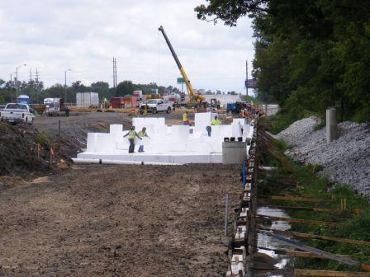
Filename: InsulFoam GF EPS geofoam --INDOT I-80_65 Interchange Gary, IN - 069
Caption: The I-80 / I-65 interchange in Gary, Indiana, used EPS geofoam for a solid foundation over soft soils.

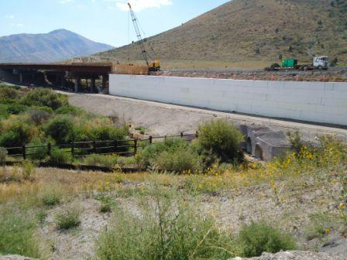
Filename: InsulFoam GF EPS geofoam -- TOPAZ AUG 23 2010 52
Caption: Contractors used EPS geofoam in eastern Idaho’s U.S. 30 Topaz Bridge to remediate soft soils and reduce lateral loads on a retaining wall.

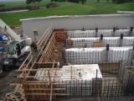
Filename: InsulFoam GF EPS geofoam -- Fairfield-Suisun Sewer District 005
Caption: EPS geofoam provides a fast and simple way to form concrete walls as seen in these water channels in a California water treatment plant.

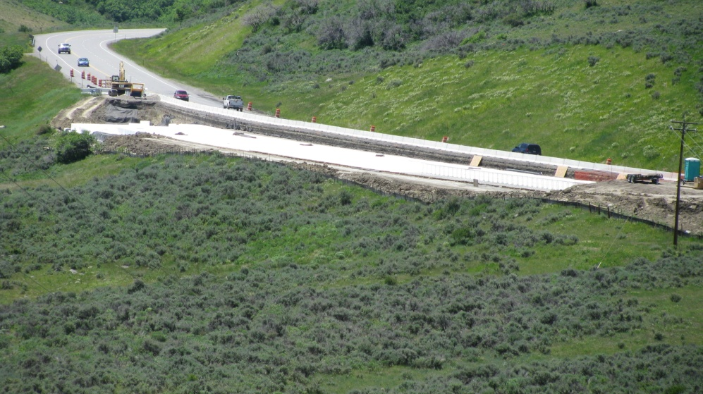
Caption: EPS geofoam used on the US 50 near Montrose, CO for the slope stabilization in the area.

